目录

Introduction to AI 2

一、Things about AI 2

二、Applications of AI 6

三、Some other things 8

Decision making 9

一、Logic and uncertainty 9

二、Probability theory 10

三、Random variables & Probability & Bayer’s 12

ML 14

一、Many kinds of learning 14

Supervised Learning 16

一、Decision Trees 16

二、Classification 20

RL 23

一、Introduction 23

二、MDP 25

三、Value-based RL 26

四、Policy-based RL 28

DL 29

一、Introduction 29

二、Elements of NN 31

三、Activation Function 33

四、Tasks in training NN 35

五、Loss function 36

六、Gradient descent (vanilla GD) 37

七、GD optimization 39

八、Overfitting 41

九、NN architectures 43

Practical AI Applications 45

Computer Vision 48

一、Basics 48

二、Basic Operations & Concepts 51

三、Image Classification 53

四、Semantics Segmentation 54

五、Object Recognition 55

Natural Language Processing 56

一、Introduction 56

二、DL for NLP 59

三、NLP applications 62

Limitations & Future 63

# Introduction to AI

## 一、Things about AI

1. 什么是AI

（1）the science and engineering of making intelligent machines

（2）use computers to understand human intelligence

（3）use computer science and robust datasets to solve problems

2. 什么是weak AI

（1）weak AI = Narrow AI = Artificial Narrow Intelligence (ANI)

（2）focused to perform specific tasks

（3）例子：alexa、SIRI都属于这个

3. 什么是Strong AI

（1）strong AI = AGI + ASI

（2）还不存在

4. 什么是AGI

（1）AGI = Artificial General Intelligence = general AI

（2）have an intelligence **equal to** human

（3）have self-aware consciousness

5. 什么是ASI

（1）ASI = Artificial Super Intelligence = superintelligence

（2）**surpass** the intelligence and ability of human

6. AI的四种程度

（1）Reactive machines 作出反应

no memory can't use past experiences to inform future ones

task-specific

例子：IBM的chess program

（2）Limited memory 一点点内存

have memory use past experience to inform future decisions

例子：decision-making functions in self-driving cars

（3）Theory of mind 有思想

have social intelligence to understand emotions

infer human intentions and predict behavior

（4）Self-awareness 有自我意识

have a sense of self and consciousness

understand their current state

不存在

7. AI的基础学科是什么？

philosophy 哲学

math 数学

economics 经济学

linguistics 语言学

neuroscience 神经学

psychology 心理学

control theory 控制理论

8. AI是如何工作的？

learning

reasoning

self-correction

creativity

9. AI的分支？

AI > ML > DL

10. AI有什么优点

（1）good at **detail-oriented** jobs 细节控

（2）deliver **consistent results** 一致性

（3）**save labour** and **increase productivity** 节约劳动力提高生产力

（4）AI-powered virtual agents are **always available** 总在上班

（5）**reduced time** for data-heavy tasks 节省时间

（6）improve customer satisfaction through **personalization** 个人化

11. AI有什么缺点

（1）**Expensive** 贵

（2）requires deep technical **expertise** 难

（3）**limited** supply of qualified **workers** to build AI tools 人才少

（4）reflect the **biases** of its training data 偏见

（5）lack of ability to **generalize** from one task to another 不通用

（6）eliminates human jobs, increase **unemployment** rates 抢工作

12. AI在ethics方面会遇到的问题？

（1）Misuse 不当使用

（2）Legal Concerns 法律

（3）Data Privacy 数据隐私

（4）Job Displacement 取代工作

（5）Training Bias 偏见

（6）Interpretability 不可解释

13. 详细解释

（1）Misuse

used for malicious purposes

例子：create deepfakes、phishing attacks

（2）Legal Concerns

AI-generated libel and copyright infringement 诽谤和侵权

需要健全的法律来解决这个问题

（3）Data Privacy

在banking、healthcare、law领域的AI应用rely on vast amounts of sensitive data

保证对数据隐私的保护并且遵循相关法规对保护个人隐私很重要

（4）Job Displacement

automation enabled by AI能导致job losses and significant disruptions in the workforce

帮助人们提高技能，或者学习别的技能很重要

（5）Training Bias

can perpetuate biases present in the training data

导致unfair or discriminatory结果

例如：会把he和doctor联系起来，而不是使用性别中立的语言

（6）Interpretability

Deep Learning和GAN (generative adversarial network)的AI算法can be difficult to interpret

这在具有法规遵从性要求的行业中提出了挑战，在这些行业中，可解释性是满足法律义务所必需的。

2324Q1 b

14. 如何解决AI 的ethical challenge

（1）responsible AI development

（2）robust **regulations**

（3）ongoing **monitoring**

（4）**transparency**

（5）stakeholder engagement

15. AI为什么很重要

（1）Potential to Transform： 有潜力改变很多行业

revolutionize various aspects

（2）Business Automation： 业务自动化

used in businesses to automate tasks

例子：customer service、lead generation、 fraud detection、 quality control

（3）Superior Performance： 杰出表现

quickly analyse large volumes of documents

例子：repetitive and detail-oriented tasks

（4）Efficiency and Accuracy 效率高，准确率高

complete tasks quickly with few errors

场景：analyse extensive data sets

（5）Generative AI Tools 生成式AI

innovative solutions and creative outputs

场景：education、marketing、product design

## 二、Applications of AI

1. AI的应用有什么？

（1）ML

act without explicit programming

（2）DL

automates predictive analytics

（3）CV

see and analyse visual information

（4）Text, Image, Audio Generation

Generative AI

（5）Healthcare

improve diagnoses

mine patient data

（6）Business

enhance customer service

AI有潜力revolutionize product design and disrupt business models

（7）Education

automates grading

adapts to student needs

provide additional support

（8）Law

document classification

data description

outcome prediction

（9）Entertainment and Media

targeted advertising

content recommendation

script creation

automated journalism

movie production

2. RL有什么应用

（1）Self-driving Cars

使用CV，image recognition, DL来navigate + avoid obstacles

trajectory optimization

motion planning

controller optimization

learning policies for parking, lane changing, overtaking

AWS DeepRacer

（2）Industry Automation 工业自动化

automate repetitive, rules-based tasks, expanding task volume and types

DeepMind cooling Google Data Center

（3）NLP

process human language by computer programs

question answering

text summarization

machine translation

translation

sentiment analysis

speech recognition

（4）Finance and Trading

automate trading

make financial decisions

IBM’s RL-based platform for financial trades

（5）Healthcare

provide treatment policies for patients

dynamic treatment regimes and medical diagnosis

（6）News Recommendation 新闻推荐

track user preferences for personalized news recommendations

考虑的因素：news features, reader behavior, context

（7）Gaming

AlphaGo通过self-play掌握了the game of go

（8）Bidding and Marketing 竞价与营销

enables real-time bidding to balance the trade-off between the competition and cooperation among advertisers

（9）Robotics Manipulation 机器人操作

让机器人抓取许多种没有在训练中见过的物体

## 三、Some other things

1. 科学技术的grand challenges是什么？

（1）understand the brain

（2）reasoning, cognition, creativity

（3）create intelligent machines

2. 什么是Turing Test

（1）rule: a judge talks with a human and a machine

（2）goal: the judge tries to determine whether he is talking with a human or a machine

3. Turing Test的优缺点？

（1）优点： serve as a method to assess the level of AI

（2）缺点： focus solely on external behavior

influenced by subjective judgements

2223 Q1

4. 冯诺依曼结构Von Neumann Architecture

input -- CPU -- output

|

memory unit

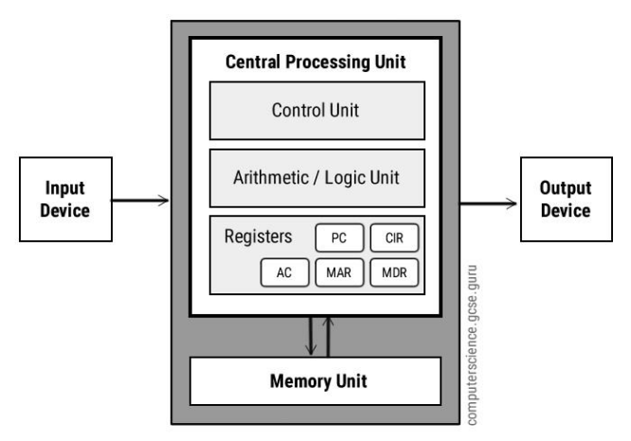

# Decision making

## Logic and uncertainty

Ps 12/19 看不懂捏 就更不可能背下来了

1. 什么是uncertainty

没有explicitly considered in the agent’s knowledge base的summary

2. uncertainty必然出现的原因

an agent’s **incomplete** or **incorrect** understanding of its environment

3. uncertainty的类型

（1）in prior knowledge 先验知识 some causes of a disease are unknown

（2）in actions actions are arbitrary

（3）in perception 感知 sensors don’t return exact or complete information

4. 解决uncertainty的方法

（1）Default reasoning 乐观的 abnormalities are rare 假设异常情况很少发生

（2）Worst-case reasoning 消极的

（3）Probabilistic reasoning 现实的

5. 讲讲Worst-case reasoning

做最坏打算，然后选择能在最坏的情况下还能得到最好结果的行动。

选择最大化效用函数的行动 maximize a utility function

这种策略在处理不确定性和风险时非常有用，可以帮助我们避免最坏的结果。

缺点：

not worth the effort

waste resources

restricted way of handling an emergency会限制我们应对突发事件的方式，因为我们总是在准备最坏的情况，而不是灵活地应对实际发生的情况

6. 为什么application fails?

（1）Laziness too much work, too hard to use 懒惰

（2）Theoretical ignorance no complete theory (medical science) 理论上

（3）Practical ignorance not all tests can be run 实践上

## 二、Probability theory

1. 什么是Decision theory

Decision theory = utility theory + probability theory

决策理论 = 效用理论 + 概率理论

2. 什么是utility theory

represent and infer preferences

3. conditional probability



题目1

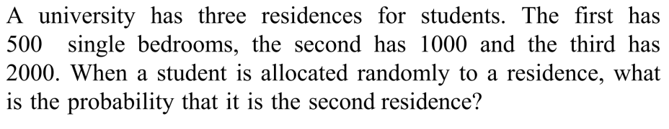

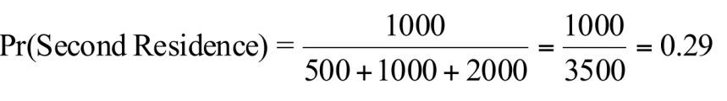

题目2

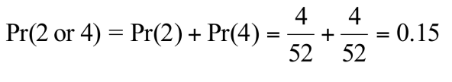

题目3

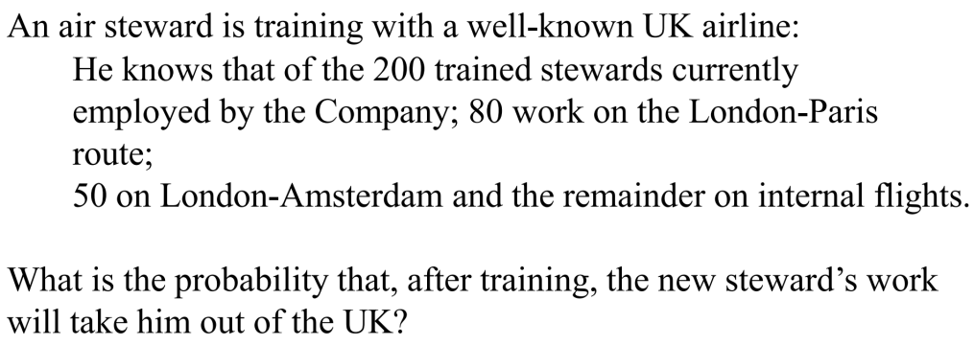

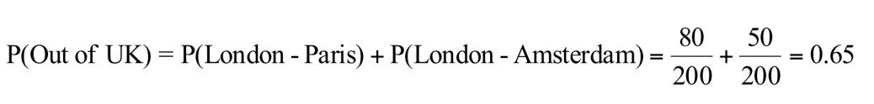

题目4

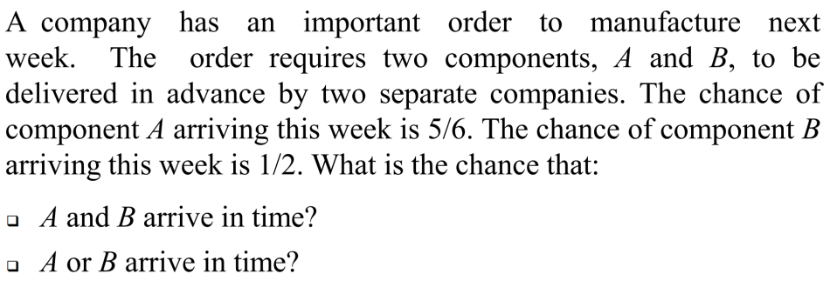

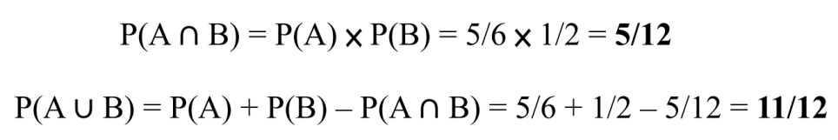

题目5

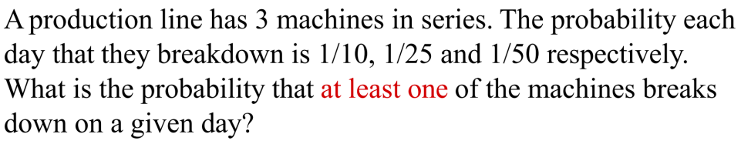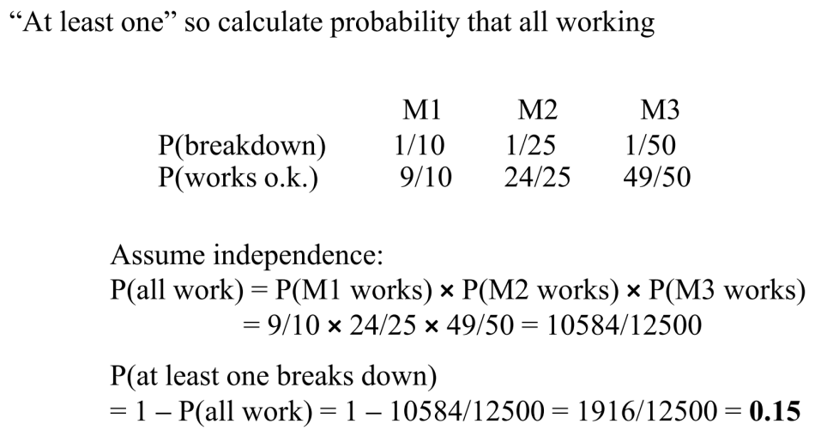

题目6

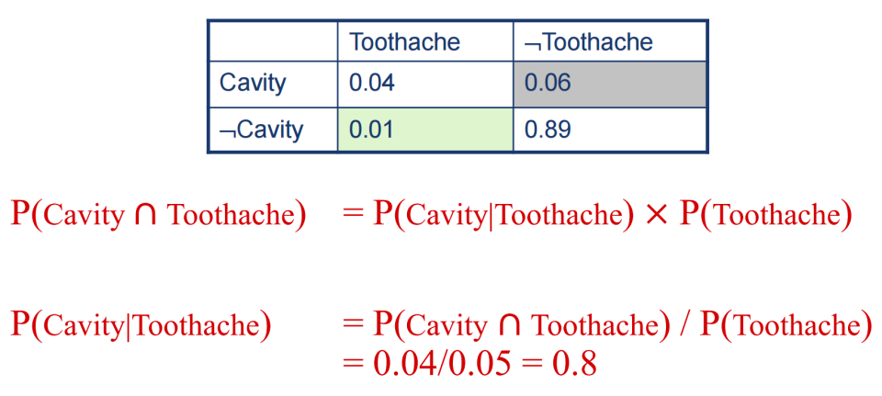

## 三、Random variables & Probability & Bayer’s

1. 什么是Random variables

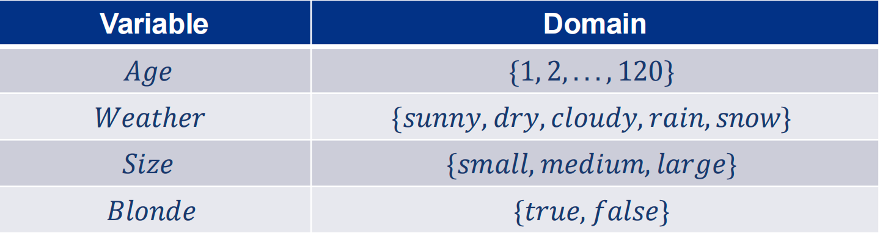

2. 什么是Probability distribution

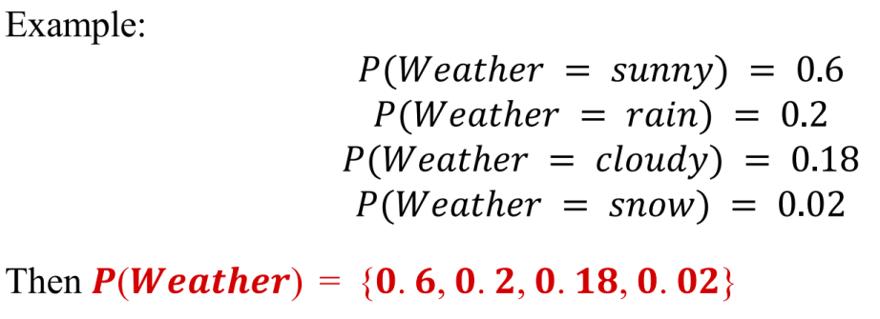

P (Weather): a probability distribution for the random variable Weather

3. 什么是Expected value

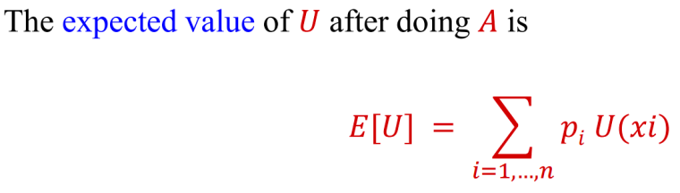

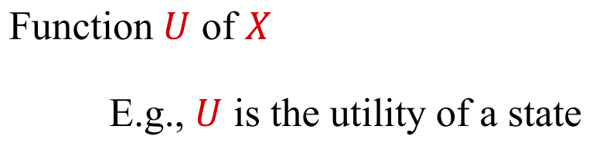

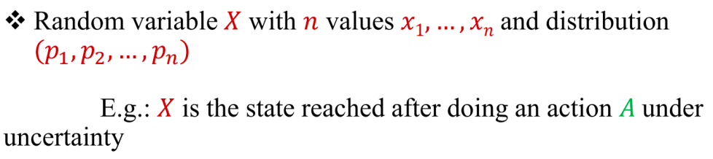

4. 什么是JPD

（1）Joint Probability Distribution

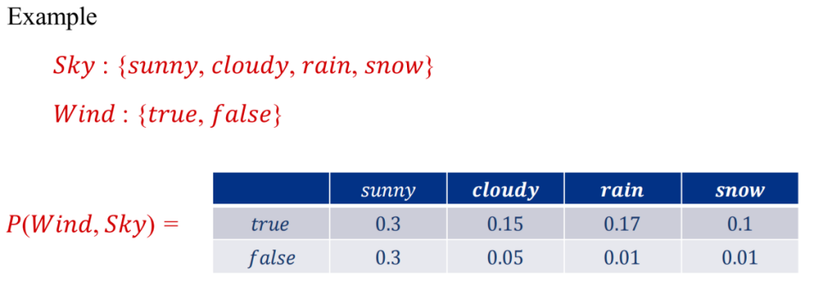

（2）例题

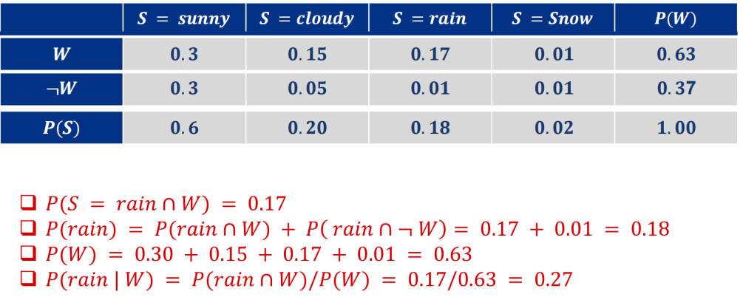

最下面的那个容易算错

（3）例题

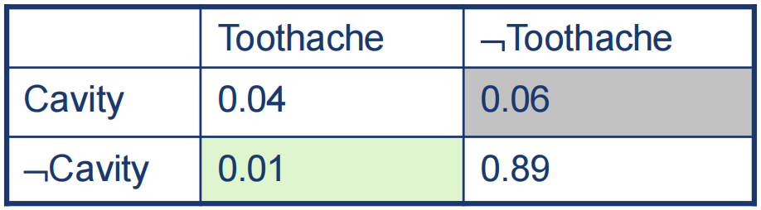

P(Toothache) = 0.04+0.01= 0.05

P(Toothache $∪ Cavity$) = 0.04+0.01+0.06 = 0.11

𝑾𝒆

5. 什么是Bayer’s rule

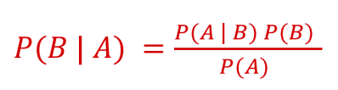

6. 什么是CPT

conditional probability table

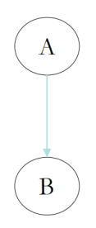7.例题

A是independent of B P( A )

B是conditionally dependent on A P( B|A )

P( $¬A)$ = 1 - P( A )

P( $¬B|A)$ = 1 - P( B|A )

P( $¬B|¬A)$ = 1 - P( B| A )

其实就是把最前面的字母加否定，其他的字母不用动

# ML

## 一、Many kinds of learning

1. 什么是学习

goal-directed process of a system that

improves the knowledge by exploring experience and prior knowledge

2. 什么是ML

（1）create an algorithm that can learn from data + make decisions based on patterns observed

（2）need human intervention

（3）rely on human-designed feature representations

（optimize weights to make a best final prediction优化一下权重）

3. 什么是DL

（1）use an artificial neural network to reach accurate conclusions

（2）no human intervention

（3）use multiple layers to learn data representations

（4）a subfield of ML

4. 什么是Supervised Learning

（1）learn with **labeled** data

（2）observe **input-output pairs** and learn **a function** that maps from input to output

（3）suitable for **predictive data labeling**

（4）例子： **classification** （email, image）

**regression** （predict real-valued outputs）

**object detection**

**semantic segmentation**

**image captioning**

5. 什么是Unsupervised Learning

（1）discover patterns in **unlabeled** data

（2）learn the hidden features, structures of data **without feedback**

（3）suitable for **describing data**

（4）例子： **clustering**

**dimensionality reduction**

6. 什么是RL

（1）use **unlabeled** data

（2）learn from the **environment** by interacting with it

（3）perform actions based on **rewards** as **feedback**

（4）maximize the **reward** by taking right **actions**.

（5）例子：learn to play Go下围棋

7. 常见的ML有哪些？

unsupervised learning + supervised learning + reinforcement learning

8. ML是如何工作的

（1）**model**  模型

problem modelling 建模

define the assumption space

（2）**strategy** 策略

determine objective function 选函数

（3）**algorithm** 算法

solve for model parameters 调参

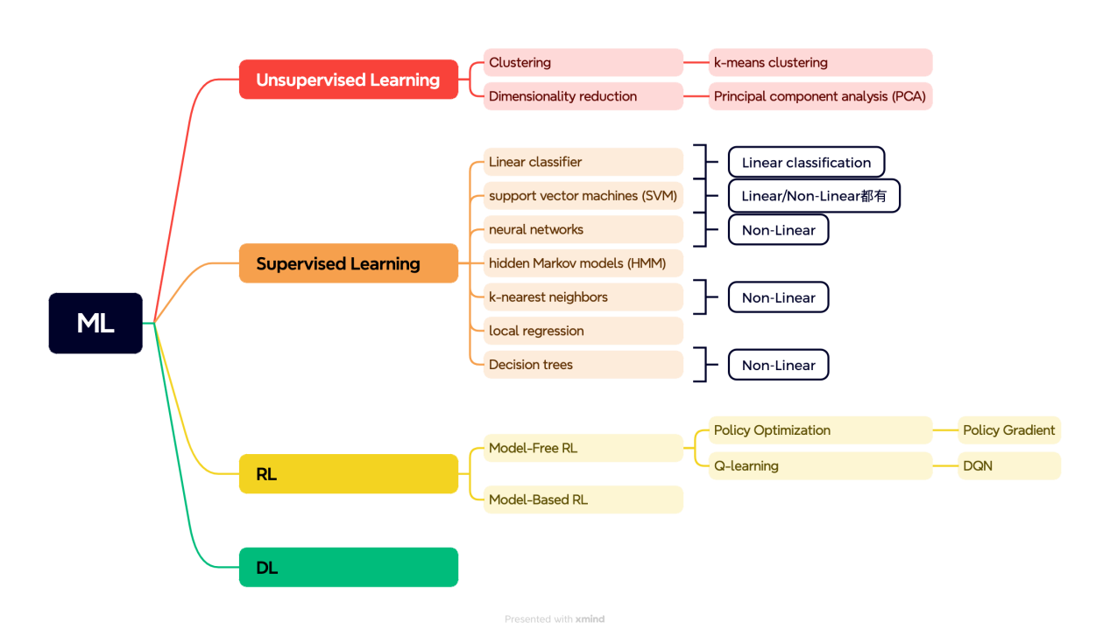

# Supervised Learning

## 一、Decision Trees

1. 什么是decision tree

（1）a simple and efficient form of learning from examples

（2）map [object with attributes] to [discrete values] according to the values of the attributes

（3）act as classifier

（4）make predictions by recursively splitting on different attributes according to the tree structure

2. Decision tree的局限性

（1）noise

（2）overfitting

（3）missing data

（4）multi-valued attributes （颜色可能是红黄蓝）

（5）continuous-valued attributes （一个人的体重在一个区间内浮动）

3. 什么是goal predicate

the predicate to be implemented by a decision tree

4. 什么是training set

the set of examples used to build the tree

5. 什么是positive example

satisfy the goal predicate

`6. 什么是information theory

help us to choose the best attribute

choose attribute that gives the highest gain

7. 什么是entropy

a measure of uncertainty, basis of constructing a decision tree

low entropy --> value sampled are more predictable

#### 7. 什么是熵（Entropy）？

熵是衡量不确定性或混乱度的标准，是构建决策树的基础。  
低熵表示样本值较为可预测，高熵则表示样本值更难预测。

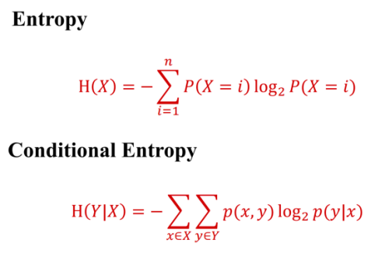

8. low entropy是什么

distribution of variable has **many peaks and valleys**

histograms have many low and highs

value sampled are more predictable

9. high entropy是什么

variable has **uniform like distribution**

flat histogram

value sampled are less predictable

10. 什么是information gain

measures the reduction in entropy by splitting a dataset according to a given value of a random variable

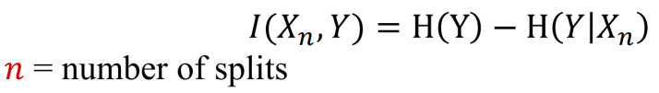

1. 最后选择information gain最大的attribute作为decision tree的root

#### 8. 低熵是什么？

低熵意味着变量的分布有很多极大值和极小值，直方图表现出许多高峰和低谷。样本值更加可预测。

#### 9. 高熵是什么？

高熵意味着变量的分布类似均匀，直方图呈平坦分布。样本值更加不可预测。

#### 10. 什么是信息增益（Information Gain）？

信息增益衡量通过根据给定的随机变量的取值来分割数据集，从而减少的熵。

#### 11. 选择信息增益最大的属性作为决策树的根节点。

计算题1

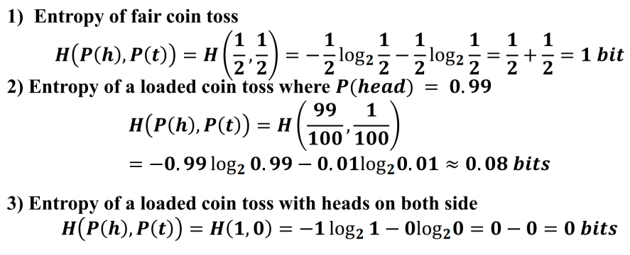

计算题2

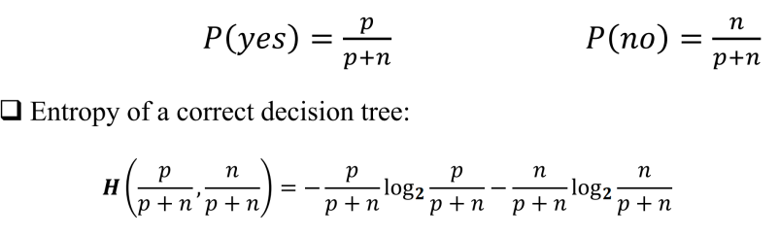

计算题3

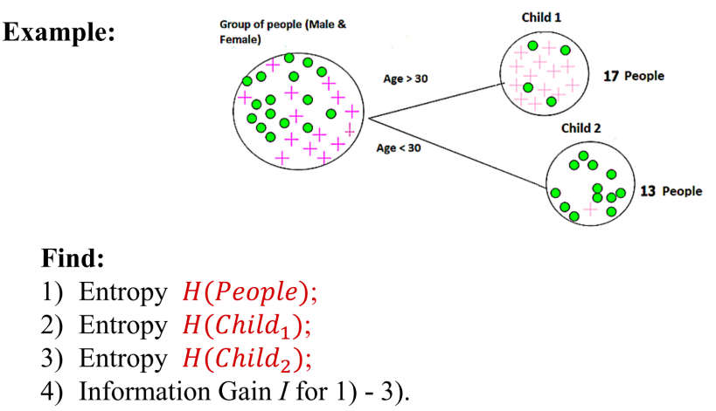

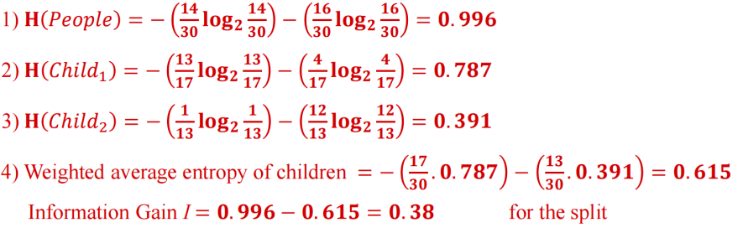

计算题4

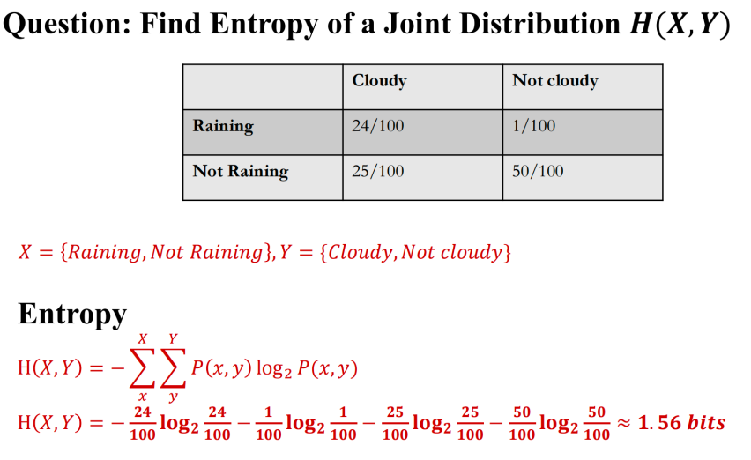

计算题5

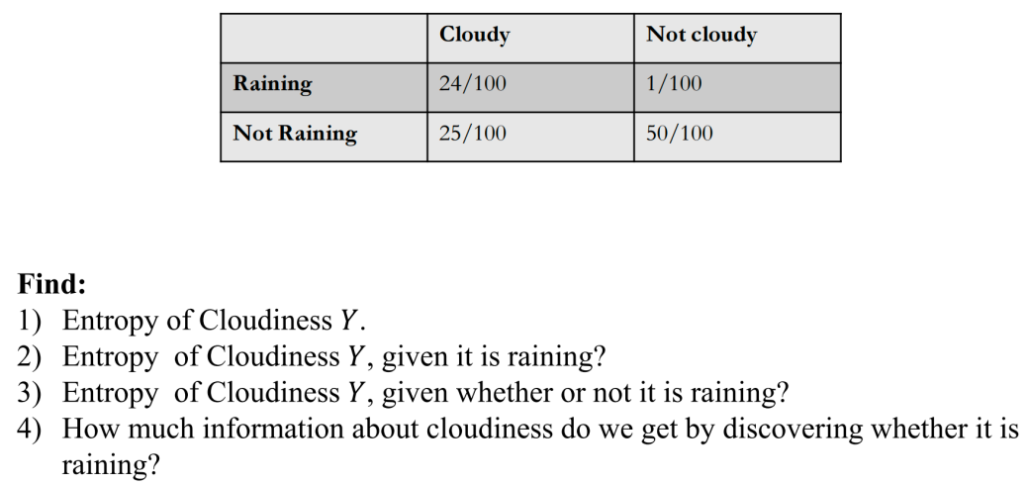

答案：

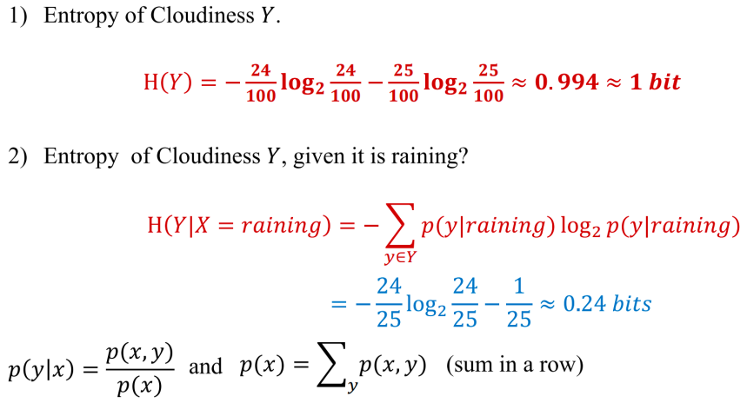

## 二、Classification

1. classification都有什么种类？

（1）nearest neighbor classifier

（2）k-nearest neighbors classifier

（3）linear classifier

（4）SVM

（5）Binary Classification

（6）Multi-class Classification

2. 什么是Nearest Neighbor Classifier

（1）assign the class label of the nearest training data point for each test data point

（2）采用一个distance function 来找到最近的neighbor

（3）每个pixel之间的距离都计算了

3. Nearest Neighbor Classifier有什么缺点

（1）must remember all training data and store it for future comparisons

（2）require comparisons between all training images

（3）expensive

4. 什么是k-Nearest Neighbors Classifier

（1）consider multiple neighboring data points to classify a test data point

（2）the class of test example is obtained by **voting** according to the distance to the 3 closest points

5. 什么是Linear

（1）input data能linearly separable的话就可以使用linear classifier

（2）线性是指可以用直线（在二维情况下）、平面（在三维情况下）或超平面（在更高维情况下）表示的关系。在机器学习中，线性模型是指模型的输出是输入特征的线性组合。

6. 什么是Non-Linear

（1）result in non-linear decision boundaries

（2）deal with non-linearly separable data

（3）Features are obtained as non-linear functions of the inputs

（4）非线性是指不能用直线、平面或超平面表示的关系。在机器学习中，非线性模型可以捕获输入和输出之间更复杂的关系。

7. 什么是Linear Classifier

（1）find a linear function of the inputs that separates the classes

（2）use pairs of inputs and labels to find weights matrix W and bias vector b

（3）decision boundary是线性的

2D空间里是straight line，3D空间里是flat plane，3D及以上是hyperplane

（4）是高级classification算法（SVM，NNs）的基石

（5）包括logistic regression, linear SVM, Perceptron

8. 找Linear Classifier中最好参数的方法？

Perceptron

详细讲：

（1）parameters are updated until a minimal error is reached

（2）single layer

（3）doesn’t use backpropagation（深度学习那里详细讲了）

9. 什么是support vectors

data points that define the maximum margin width

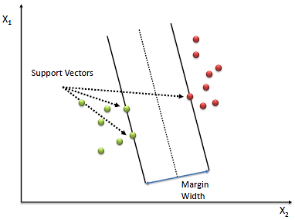

10. 什么是SVM

（1）Support Vector Machines

（2）solve optimization problem

identify a decision boundary that correctly classifies the examples

increase the geometric margin between the boundary and all examples

（3）suitable for Binary Classification

（4）find a plane to separate different kinds of data

11. 什么是Non-linear SVM

（1）[original input space] is mapped to [a higher-dimensional feature space where the training set is linearly separable]

（2）define a non-linear kernel function to calculate a non-linear decision boundary in the original feature space

（3）对于线性不可分的数据，SVM使用核技巧将数据映射到高维空间使其变得线性可分，然后在那里找到超平面。

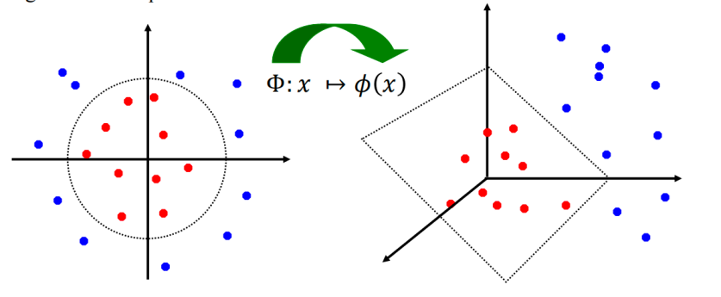

12. 什么是Binary Classification

（1）output labels: 0 or 1

（2）例子：benign or malignant tumor 良性or恶性肿瘤

spam or no-spam email 垃圾or有用邮件

（3）二分类是指分类任务只有两个类别

13. 什么是Multi-class Classification

（1）分成3个或更多种

（2）例子：手写数字识别，0到9有10个类别

（3）Binary和multi-class都可以linearly或non-linearly separate

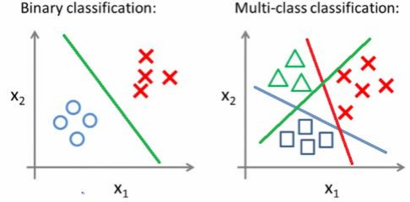 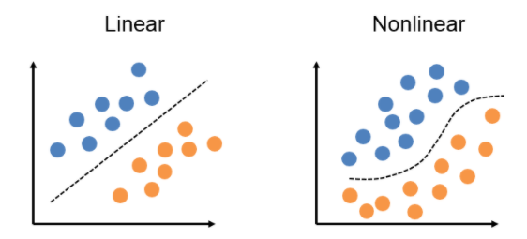

14. 什么是No-Free-Lunch Theorem

No single classifier works the best for all possible problems

# RL

## 一、Introduction

1. RL的key elements？

environment、agent、state、action、reward

2. RL的workflow？

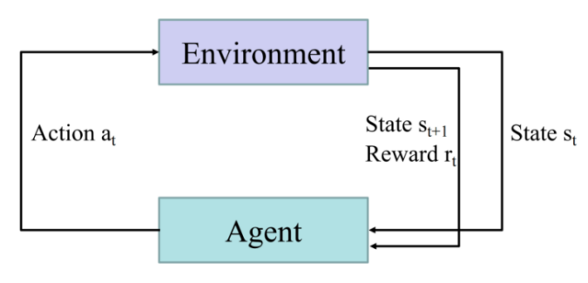

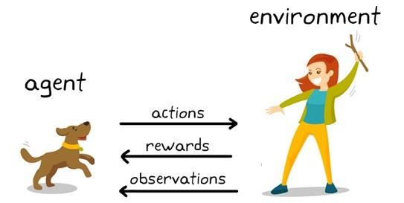

3. RL都有哪些分类？

model-based

model-free

policy-based on/off-policy

value-based

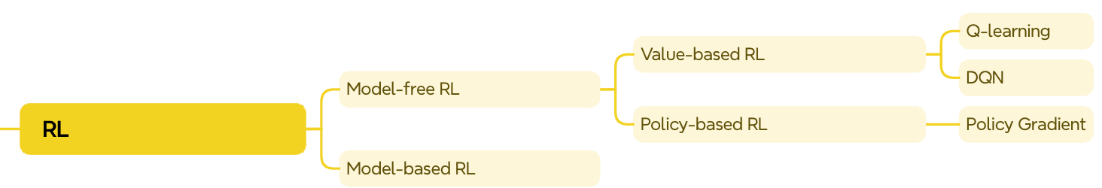

4. 什么是Model-free RL

（1）learn strategies directly **without** **explicit model of the environment**

（2）agent interacts with the real environment

（3）rely on real environment feedback and reward

（4）例子：learn from doing and interacting with the real world

5. 什么是Model-based RL

（1）**model the environment** and plan future actions

（2）agent constructs a simulated model

（3）收到的信息是transition probability和reward

（4）例子：theorize in our mind before taking an action

6. 什么是Value-based RL

（1）select the action that has the highest value function in a given state

（2）优点：find the optimal policy **efficiently**

have high sample efficiency

缺点：can’t solve problem with continuous action space

sensitive to hyperparameters

7. 什么是Policy-based RL

（1）select actions directly by learning policy functions

（2）优点：deal with **continuous** action spaces

easier to converge in real environment

缺点：require more training data

often converge to a local optimum

8. 什么是On-policy RL

（1）learn from the policy that is currently followed during exploration

（2）例子：learn from our own experience

9. Off-policy RL

（1）learn from a different policy instead of the currently followed one

（2）learn from others to gain experience

## 二、MDP

1. 什么是Markov Process / Markov Chain

（1）a stochastic model describing a sequence of possible events

（2）the probability of each event is only related to the state attained in the previous event

（2）stationary assumption: state transition probabilities has nothing to do with time

2. 什么是MDP

（1）Markov Decision Process

（2）是RL的mathematical description

（3）定义：<S,A,R,P, $γ$ >

S: states

A: actions

R: reward

P: transition probability

$γ$: discount factor in [0,1] 如果重视long-term回报，那么就让大一点

3. MDP的过程？

environment initializes a state at time step t=0

agent selects action at

environment returns reward r

environment gives next state st+1

agent receives reward rt and next state st+1

4. Deterministic和Stochastic的区别

（1）Deterministic: 下一个state和相应reward只被现在state以及选择的action有关

（2）Stochastic: 下一个state和相应reward被a probability distribution决定

## 三、Value-based RL

1. 什么是 state value function?

（1）expected accumulative reward an agent can obtain in the current environment state

（2）help the agent evaluate the goodness of states to make better decisions

（3）评估一个state

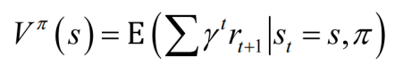

2. 什么是Q-value function？

（1）expected accumulative reward form taking action a at state s

（2）也叫state-action value function

（3）评估一个state-action pair

（4）给一个state and action作为input，然后就会output Q-value

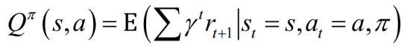

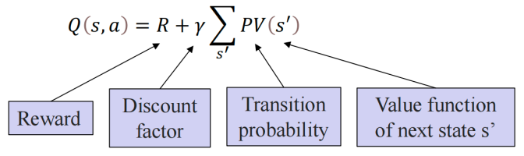

3. 什么是Bellman equation

（1）help agent to iterate on value, thus optimizing the policy

（2）现在的reward加上expected reward from the future actions

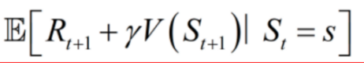

4. 什么是Q-learning

（1）use function approximator to estimate Q-value function

（2）function approximator是一个Q-table

（3）步骤

initialize the Q-table

[choose an action

execute the action and obtain a reward

update the Q-value in Q-table]循环

5. 什么是Deep Q-learning

（1）使用DQN（Deep Q-network）

（2）function approximator是一个DNN

（3）有太多states或continuous state space的时候，我们不能列出所有的state-action pair in the Q-table

所以使用DNN (deep neural network) 来make decisions in extremely large domains

（4）represent value function by Q-network with weights $ω$

（5）用SGD (stochastic gradient descent) 来optimize loss function

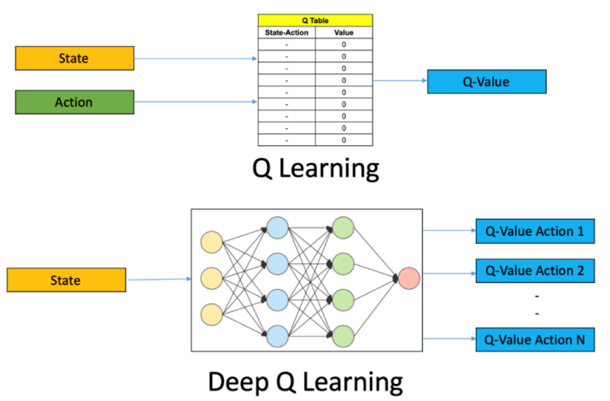

6. 训练DQN有什么方法？

（1）experience replay 经验回放

（2）fixed Q-target 固定Q目标

7. 什么是experience replay

（1）把每一个状态转变和决策存储在一个叫做经验回放内存的数据结构中。

在训练时不使用最新的经验，而是从这个内存中随机抽取一部分经验来进行学习。

好处：打破数据之间的关联性，提高学习的稳定性。

（2）remove correlations of training data的方法：

store dataset from prior experience

（3）步骤

a. sample an experience tuple from the dataset

b. compute the target value for the sampled state

c. use SGD to update the network weights

8. 什么是Fixed Q-target

（1）为了增加稳定性，fix the target network weights

## 四、Policy-based RL

1. 什么是policy

a function from S to A that specifies what action to take in each time

2. optimal policy的目标是什么？

find an optimal policy that maximizes accumulative discount reward

3. 什么是policy gradient

define a class of parametrized policies

define its value based on the discounted accumulative reward

do gradient ascent on policy parameters唯一的梯度上升

4. Policy-based RL比Value-based RL有什么优点

（1）Value-based的Q-function可能会很复杂，不可能算出每个state-action pair的value

例如：a robot grasping an object有high-dimensional的state和action

（2）可以直接学习一个policy，简单很多

5. 什么是Actor-critic architecture

（1）combine value-based and policy-based

（2）actor: decide which action to take in a given state, learn the policy

critic: evaluate the value of the action at the state, estimates the value function

# DL

## **一、Introduction**

1. 深度学习的原理

apply a multi-layer process to learn rich hierarchical features

例子：data representations

2. 深度学习的过程

Input → Feature extraction + Classification → Output

3. 机器学习和深度学习的过程区别

ML的feature extraction是人做的

4. 深度学习的优点/特点，为什么深度学习有用

（1）require large amounts of training data

（2）learn in supervised and unsupervised manner

（3）**effective** at learning patterns

（4）represent an effective **end-to-end learning system**

（5）provide a **flexible**, learnable framework to represent visual, text, linguistic information

（6）**outperform** other ML techniques

5. 什么是神经网络（neural networks）（NN）

（1）NN can approximate any complex continuous function

（2）use nonlinear mapping of the inputs x to the outputs f(x) to compute complex decision boundaries

6. 什么是Deep神经网络

（1）有许多hidden layers

（2）Fully-connected layers (也即Multi-Layer Perceptron or MLP)

（3）Each neuron is connected to all neurons in the succeeding layer

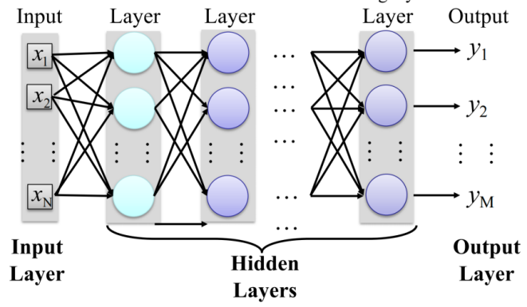

7. 为什么用deep NN？

（1）实际上deep NN更好只是个empirical observation

（2）数学上，deep的和one-layer的representational power一样

（3）deep的表现更好，但是在a certain number of layers之后，the performance plateaus

8. 什么是MNIST

（1）[MNIST: Modified National Institute of Standards and Technology database](https://zhuanlan.zhihu.com/p/264960142)

（2）是NN的一个例子

（3）是一个handwritten digit recognition

（4）input: the intensity of each pixel 每个像素的强度

（5）output: the class of the digit 数字的类，也就是哪个数字

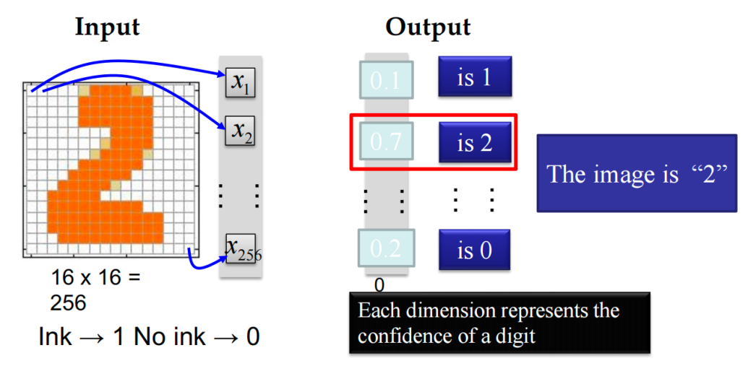

每个维度表示数字置信度，出来的是一个概率，70%的可能是2

## 二、Elements of NN

1. 神经网络的elements是什么？分别有什么作用？

（1）neurons fundamental units of NN, map inputs into an output number

（2）layers facilitate the [structured arrangement and processing] of data

（3）weights parameters that **transform** input data

（4）biases parameters that allow for **greater flexibility**

（5）activation functions introduce non-linearities

2. 重要公式

:

W: weights

x: input

b: bias

a: output

3. 需要会画的diagram：

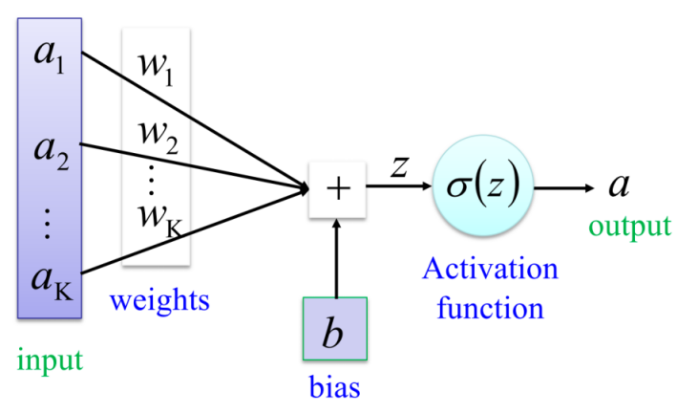

4. 算neurons例子：

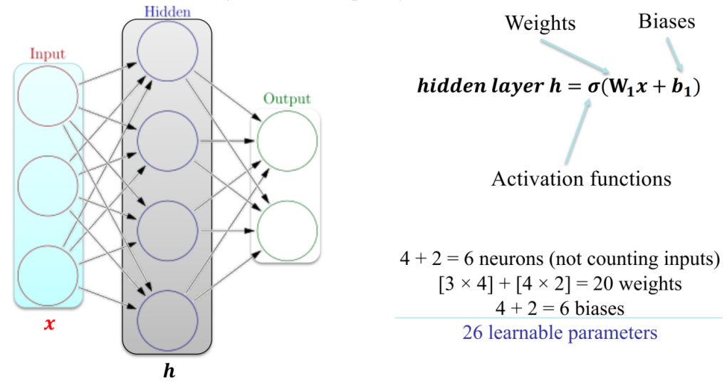

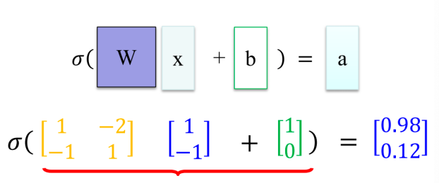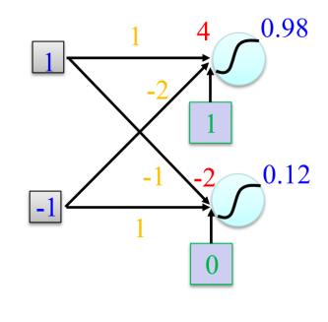

5. 太多neurons的优缺点：

（1）优点：improve representation

（2）缺点：may overfit

## 三、Activation Function

1. 常用的激励函数有什么？

（1）Linear function the output signal is proportional to the input signal

（2）Sigmoid function [0,1]

（3）Tanh function [-1,1]

（4）ReLU threshold at zero

2. 什么是Linear function f(x) = cx

（1）用在regression problems里面

（2）the output signal is proportional to the input signal

（3）如果c=1，线性激励函数就叫identity activation function恒等激励函数

3. 什么是Non-linear activations

（1）用在non-linear data representations里面

（2）NN with large number of layers can approximate complex functions

4. 什么是Sigmoid function（s形的） f(x) = $\frac{1}{1+e^{−x}}$

（1）squash a number into the range between 0 and 1

（2）用的少（less common in modern NNs）

（3）When the neuron’s activation is 0 or 1, sigmoid neurons saturate

Gradients at these regions are almost zero

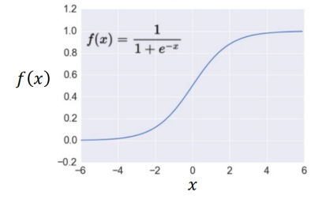

5. 什么是Tanh function tanh(x) = $\frac{2}{1+e^{−2x}}−1$

（1）squash a number into the range between -1 and 1

（2）the output is zero-centered（对称，所以比sigmoid更好）

（3）和sigmoid一样会saturate

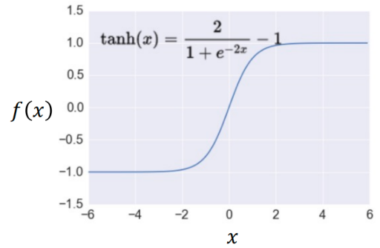

6. 什么是ReLU (Rectified Linear Unit） f(x)= $\left\{\begin{aligned}0, x<0 \\ x, x≥0\end{aligned}\right.$

（1）take a real-valued number and threshold at zero（从0开始）

（2）form: linear+non-saturating上面没有平台，所以不会saturate

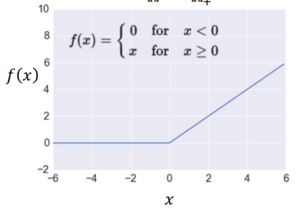

7. ReLU的优缺点？

（1）优点：

fast to compute than others

threshold a matrix at zero

accelerate the convergence of gradient descent

prevent the gradient vanishing problem (linear, non-saturating)

（2）缺点：

the gradients can become zero and the neuron will not activate again

例：learning rate太大的时候

8. 什么是Leaky ReLU

（1）x < 0时有small slope(0.01的斜率什么的)

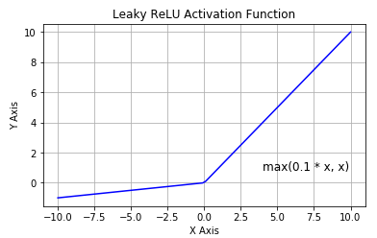

9. 什么是Softmax

（1）output a probability value between 0 and 1

（2）Probability:

0 < yi < 1

∑i yi = 1

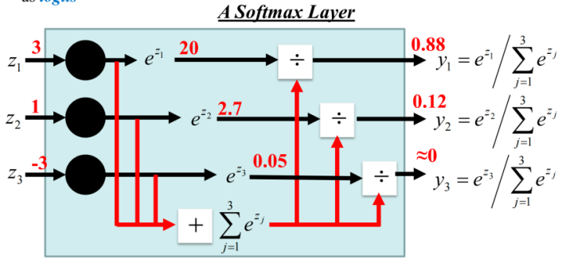

## 四、Tasks in training NN

1. 为什么要训练NN

To train a NN, set the parameters $θ$ such that for a training subset of images, the corresponding elements in the predicted output have maximum values

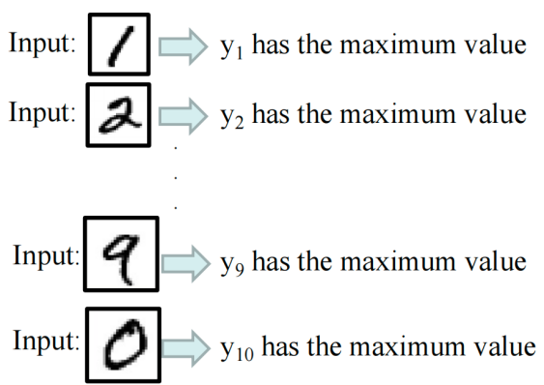

2. 机器学习的难点：Train a model to learn a set of parameters $θ$ that are optimal

3. 参数 都有什么

weight matrices and bias vectors from all layers



（公式：）

4. 什么是Data preprocessing

（1）help convergence during training

（2）Mean subtraction（水平垂直居中对齐）

结果：obtain zero-centered data

方式：subtract the mean for each individual data dimension (feature)

（3）Normalization （拉伸）

方式1：Divide each feature by its standard deviation

方式2：scale the data within the range [0,1] or [-1, 1]

结果：obtain standard deviation of 1 for each data dimension (feature)

例：image pixel intensities are divided by 255 to be scaled in the [0,1] range

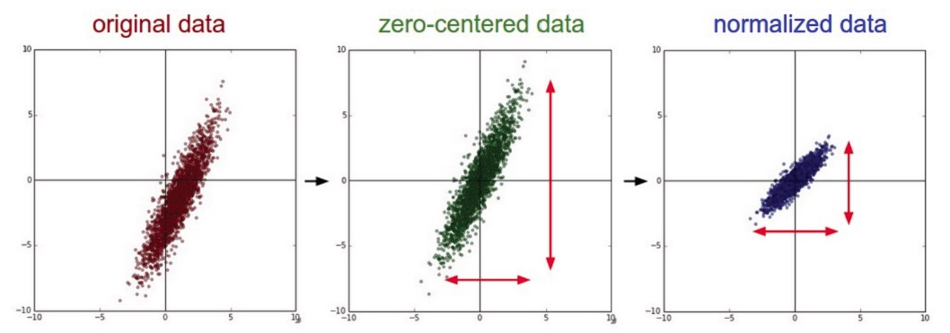

## 五、Loss function

1. 什么是loss function

（1）calculate the difference between the model prediction and the true label

（2）可以是mean-squared error, cross-entropy

（3）如果有N个图片的训练集，计算total loss over all images: *L() =*

2. Classification Tasks的loss function是什么

（1）Cross-entropy

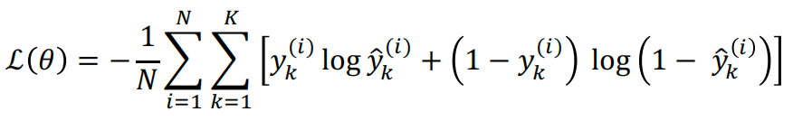

（2） $y_{i}$ 是ground-truth class labels

$\hat{{ y}_{i}}$ 是model predicted class labels

3. Regression Tasks的loss function是什么

（1）mean squared error或mean absolute error

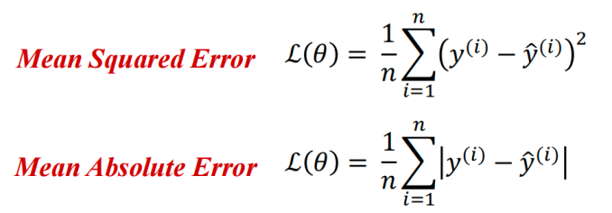

## Gradient descent (vanilla GD)

## "Vanilla"是指原版、未经过修改的状态

1. 什么是梯度下降算法？

（1）find the optimal parameter $θ$ to minimize the loss

（2）apply iterative refinement of the parameter $θ$ 迭代细化

（3）use the opposite direction of the gradient of the loss function to update $θ$

例： $∇L(θ) = \frac{∂L}{∂θ_{i}}$

（4）The gradient of the loss function $∇L(θ)$ gives the direction of fastest increase of the loss function

2. GD算法的步骤？

（1）Randomly initialize the parameters, $θ^{0}$

（2）Compute the gradient of the loss function using backpropagation at the initial parameters $θ^{0}$： $∇L(θ^{0})$

（3）Update the parameters: $θ^{new}= θ^{0} − α∇L$ ($θ^{0}$) ( α is the learning rate )

（4）Go to step 2 and repeat

3. GD的问题

（1）the local minima problem

（2）very slow at plateaus $∇L(θ)≈$ $0$

（3）get stuck at saddle points $∇L(θ)=$ $0$ 鞍点

（4）Vanishing/Exploding Gradient Problem

4. 什么是backpropagation

（1）calculate the gradient of the loss function

（2）traverse the network in reverse order

(from the outputs y backward towards the inputs x 来计算 $∇L(θ)$

（3）each update for $θ$ takes one forward and one backward pass

（4）题外话，现在scikit-learn有automatic calculation of the gradients, 不需要手算

5. backpropagation有什么缺点

（1）wasteful to compute the loss over the entire training dataset to perform a single parameter update for large datasets. （例：ImageNet有14M images）

6. back propagation用在了哪里？

（1）GD算法用了

（2）RNN那里也用了

（3）Perceptron没用

7. 什么是forward propagation

pass the input x through the hidden layers to obtain model outputs y

8. 什么是Learning Rate

（1）gradient: 告诉我们direction in which the loss has the steepest rate of increase

（2）learning rate: 告诉我们how far along the opposite direction we should step

9. learning rate快慢的影响？

（1）太快：the loss increases or plateaus too quickly

（2）太慢：the loss decreases too slowly + takes many epochs to reach a solution

10. 什么是local minima problem

（1）stop when a local minimum of the loss surface is reached

（2）don’t guarantee a global minimum

（3）loss surface $L(θ)$ can be complex

（4）random initialization in NN will cause different initial parameters $θ^{0}$

each GD may result in different minima

NN may produce different outputs

11. 什么是Vanishing/Exploding Gradient Problem

（1）梯度太小Vanishing，导致很小的update of the parameters，学的很慢

（2）梯度太大Exploding，导致很大的update of the parameters

12. 怎么解决Vanishing/Exploding Gradient Problem

（1）change learning rate

（2）ReLU activations (linear, non-saturating)

（3）Regularization（也解决过拟合）

（4）LSTM （有一个memory cell, update at each step in the sequence）

13. 什么东西mitigate了Vanishing/Exploding Gradient Problem

（1）ResNet vanishing

14. 什么东西会出现Vanishing/Exploding Gradient Problem

（1）GD vanishing/exploding

（2）RNN vanishing

## 七、GD optimization

1. 梯度下降法的optimization methods有哪些？

（1）mini-batch GD

（2）stochastic GD with momentum

（3）Adam

2. Mini-batch GD的步骤

（1）compute the losson a mini-batch of images

（2）update the parameters $θ$

（3）repeat until all images are used

（4）at the next epoch, shuffle the training data and repeat the above process

3. Mini-batch GD的优点

（1）faster training

4. Mini-batch能用的原理

（1）the gradient from a mini-batch is the gradient from the entire training set

5. 什么是Stochastic Gradient Descent

（1）use mini-batches that consist of a single input example

例：one image mini-batch

6. SGD的优缺点？

（1）优点：very fast

（2）缺点：may cause significant fluctuation in the loss function （所以用得少）

7. 什么是Gradient Descent with Momentum

（1）use the momentum of the gradient for parameter optimization

（3）movement = negative of gradient + momentum

8. GD with Momentum是怎么update parameter的

（1）update the parameters $θ$ in the direction of the weighted average of the past gradients

之前的GD： $θ^{new}=θ^{0} − α∇L$ ($θ^{0}$)

也就是： $θ^{t} =θ^{t−1} − α∇L(θ^{t−1}$)

现在的： $θ^{t} =θ^{t−1} − α∇L(θ^{t−1})−βV^{t−1}$

（2）V的那项就是momentum

$β$ 是个系数，通常是0.9

9. momentum有什么作用

（1）accumulate the gradient from the past several steps

10. 什么是Adam

（1）Adaptive Moment Estimation

（2）compute weighted average of past gradients (first moment of the gradient)

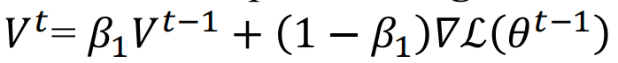

compute weighted average of past squared gradients (second moment of the gradient)

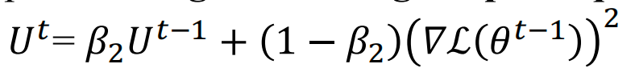

（3）parameter update:

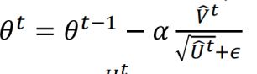

其中：

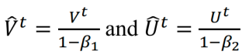

（4） $β_{1}=0.9$， $β_{2}=0.999$， $ϵ={10}^{−8}$

## 八、Overfitting

1. 什么是Generalization

underfitting或overfitting都会让通用性很差

2. 什么是Overfitting

（1）a model fits the noise in the data instead of the underlying relationship

（2）fit the training data very well

（3）fail to generalize to validation data

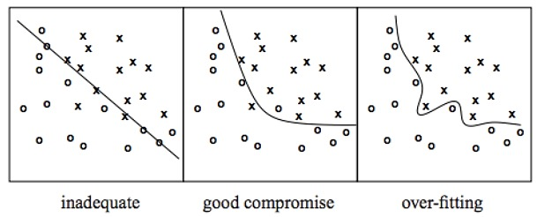

3. underfittng和overfitting有什么区别？

|  |  |  |
| --- | --- | --- |
|  | underfitting | overfitting过拟合 |
| characteristics | too simple to represent all the relevant class characteristics | too complex and fit irrelevant characteristics (noise) in data |
| parameters | 参数太少 | 参数太多 |
| training set的错误率 | high | low |
| validation set的错误率 | high | high |

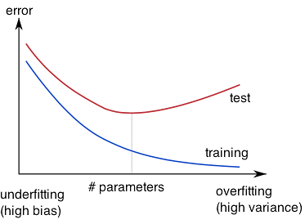

4. 怎么解决过拟合？

（1）Regularization

（2）Dropout

（3）Early Stopping

（4）题外话，CNN里面的pooling也可以防止过拟合

5. 什么情况下会出现overfit

（1）decision tree

（2）使用fully connected network, 太多neurons

6. 什么是Regularization

（1）[a regularization term that penalizes large weights] is added to the loss function

7. 什么是Weight Decay coefficient λ

（1）determine how dominant the regularization is during the gradient computation

λ大一点的效果好

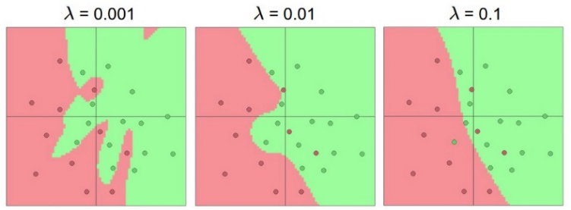

8. 什么是Dropout

（1）randomly drop some units and their connections

（2）dropout rate p

通常是20%-50%的概率drop一些unit，防止过于依赖一些特征

（3）通常在每次迭代中，对每个神经元都独立地进行是否丢弃的决定，每次的训练过程中的网络结构都有所不同。

9. 什么是Early Stopping

（1）stop when validation accuracy has not improved after n epochs

（2）一边训练一边检测validation set的正确率

（3）n叫做patience（没耐心之后就停止了）

（4）通常来说 $\frac{validation}{train} = 25\%−75\%$

## 九、NN architectures 就是一些下属

1. NN的architecture都有哪些

（1）Batch normalization layer

（2）CNN

（3）ResNet

（4）RNN

（5）LSTM

2. 什么是Batch Normalization Layer

（1）和data preprocessing数据预处理 很像

（2）calculate the mean $μ$ and variance $σ$ of input data

normalize the data to a zero mean and unit variance

3. Batch Normalization有什么优点

（1）alleviate the problems of proper parameter initialization

（2）faster convergence training

（3）larger learning rate

（4）reduce the internal covariate shift

4. 什么是CNN （CV提到）

（1）Convolutional Neural Networks卷积神经网络

（2）主要用于image data

robust to spatial translations of objects in images

（3）use a convolutional operator to extract data features

5. CNN有什么优点

（1）parameter sharing

（2）efficient to train

（3）less parameters than NNs with fully-connected layers

6. CNN的过程

a convolutional filter will slide/convolve across the image

7. 什么是pooling

卷积之后会有max pooling或者average pooling把一个区域取最大值/取平均

8. pooling的优点是什么？

（1）reduce the spatial size of feature map

（2）reduce parameters

（3）prevent overfitting

9. 这些层的位置

【convolutional layers】【max pooling layer】【fully-connected layers】【BatchNorm layers】【activation layers (softmax) 】

10. CNN一般是什么作用？

feature extraction

11. fully-connected layers和softmax一般是什么作用？

classification

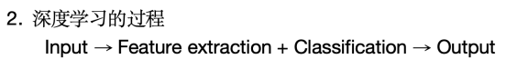

12. 什么是ResNet （NLP提到）

（1）Residual CNN

（2）introduce identity skip connections

（3）inputs are propagated in each layer and then added to the output

（4）mitigate vanishing gradient problem

（5）其他最先进NN的base model

（6）可以训练非常深的神经网络（1000多层）

13. 什么是RNN （NLP提到）

（1）Recurrent Neural Networks

（2）trained by backpropagation-through-time时间反向传播

（3）model **sequential data** + data with varying length of inputs and outputs

例如：video、text、speech、DNA sequences、human skeletal data

（4）introduce recurrent connections between neurons

（5）process sequential data one at a time by selectively passing information across a sequence

（6）capture correlations in sequential data

（7）前面的输入会被存在model’s internal state并且影响the model predictions

（8）比CNN更容易出现vanishing gradient problem

（随着序列长度的增加，梯度可能会变得非常小，导致训练过程变得非常困难）

14. 什么是LSTM （NLP提到）

（1）Long Short-Term Memory networks

（2）a variant of RNN

（3）can learn long-term correlations within data sequences

（4）mitigates the vanishing/exploding gradient problem

（有一个memory cell, update at each step in the sequence）

15. LSTM cell的组成

（1）Memory cell update at each step in the sequence

（2）Input Gate protect the current step form irrelevant inputs

（3）Output Gate prevent current step from irrelevant information to later steps

（4）Forget Gate limit information passed form on cell to the next

# Practical AI Applications

1. 什么是scikit-learn

simple and efficient tools for predictive data analysis

accessible to everybody

reusable in various contexts

built on Numpy, SciPy, matplotlib

open source, commercially usable

2. scikit-learn有哪些工具？

Classification

Regression

Clustering

Dimensionality reduction

Model selection

Pre-Processing

3. regression的例子？

random forest

4. dimensionality reduction的例子？

principal component analysis (PCA)

5. DL有什么framework？

Caffe | Caffe2 | torch | PyTorch | TensorFlow | Chainer | Keras

6. 什么是Keras

high-level neural networks API

使用TensorFlow as the compute backend

included in TensorFlow 2 as tf.keras

7. 什么是tensor

a specialized data structure in DL

tensor = multidimensional array

比matrix的维度再高一阶

8. 什么是TensorFlow

an open-source DL library

easy to learn and use

9. 什么是PyTorch

open-source ML library

GPU-based tensor library, leverages the power of GPU

automatic computation of gradients

easy to test and develop new ideas

concise, close to Python conventions

implemented algorithms and components

an efficient library for dynamic neural networks

developed by Facebook

10. TensorFlow 和PyTorch对比

|  |  |
| --- | --- |
| TensorFlow | PyTorch |
| C++写的，fast and efficient | Python写的，内核是C++，**more accessible** |
| rich feature, used for training data | **flexible**, data size can be changed while training |
| strong documentation | poplar at research level |
| the most used ML library | growing rapidly |
| many **API** available | many libraries available |
| support JavaScript, C++, Java, Python | support Python |
| can be performed on **mobile devices** |  |

11. TensorFlow的training flow?

data ingestion and transformation

model building

training

saving

12. TensorFlow的programming model?

express numeric computation as a graph

nodes: operations which have inputs and outputs

edges: tensors

13. 什么是graph

（1）the computation process can be viewed as a graph

14. 什么是static graph

（1）define the entire computation graph before performing the computation

（2）Data is calculated according to the defined calculation graph

（3）no intermediate results

（4）hard to debug

（5）use specific syntax as control method

（6）**more optimization strategies** -->**better** performance

（7）**low memory usage**

（8）**direct deployment**

15. 什么是dynamic graph

（1）generate computational graphs when they are computed

（2）the complete graph is known when the computation is completed

（3）get **intermediate results**

（4）**easy to debug**

（5）use **front-end language syntax as control method**

（6）limited optimization -->poor performance

（7）large memory usage

（8）no direct deployment

16. 什么是variable

stateful nodes which output their value

17. 什么是placeholder

nodes whose value is fed in at execution time

18. operations包括什么

MatMul

Add

ReLU

# Computer Vision

## 一、Basics

1. CV是什么？

analyse pictures and videos in order to achieve results similar to those as by humans

2. CV的目标是什么

make computers understand images and video

3. CV的大体过程是怎样的

Image acquisition

Image interpretation

4. 建立CV模型的fundamental steps？

（1）data collection capture an image

（2）data cleaning noise reduction

filter the data and remove unclear pictures

（3）data preparation resize the pictures to common size

（4）build and train the model coding, identify relevant characteristics,

choose important features

（5）classification or recognition make sense of the visual information

5. CV的techniques

classification

semantic segmentation

object detection

instance segmentation

6. CV的基础操作有哪些？

Convolution

De-convolution

Dilated Convolution

Pool

Flatten

Normalization

Feature extraction

7. CV经常用的network？

AlexNet

VGGNET

ResNet

8. AlexNet的创新之处

ReLU

Normalization

Dropout regulation

max pooling

9. VGGNET创新之处

smaller filter 3*3

multiple filters within each layer

10. ResNet创新之处

fewer filters -->reduce computational complexity

11. CV有什么应用？

safety

health

security

content creation

AR VR

search engines

12. dimension是什么

the number of pixels across the image’s height and width就是长乘宽

13. pixel value是什么？

the intensity of the pixels

14. 图片的几种类型

pixel value是binary的 01串

pixel value是gray scale的 一堆小数

pixel value是color的 RGB三张图片合起来

pixel value是multimodal的

HDR images

Multispectral and Hyperspectral Images RGB的三色channel加上几个infrared channel

label images

15. 彩色图片是怎么存储的？

RGB三种颜色的图片，电脑读这仨然后合起来

16. HDR是什么？

high dynamic range

attempt to capture the whole tonal range of real-world scenes

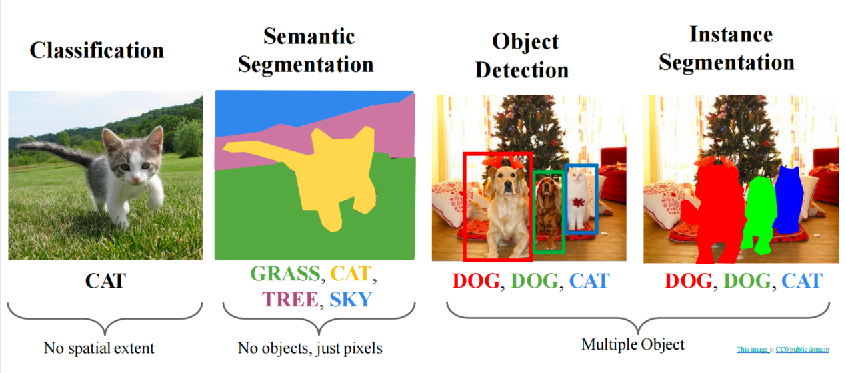

## 二、Basic Operations & Concepts

1. 使用fully connected network会有什么问题

overfitting too many parameters in the weight matrix

2. CNN的好处

local correlation 旋转拉伸也不怕

parameter sharing 都用的一个kernel，里面的数值都一样

reduce connectivity to local regions

3. Convolution的基础性质

kernel 也叫receptive field，就是那个小框

stride pixels moved by the convolution kernel at each step

padding fill the boundary

channel 也叫做layer，一共卷积多少次

4. 什么是padding

（1）主要是做题的时候会遇到，分为两种，一个是valid padding，一个是same padding

（2）valid padding就是no padding，不会添加小框框

（3）same padding会添加小框框来使得卷积后的输出尺寸与输入尺寸相同

（4）所以做题的时候看到valid padding不用管他

5. 什么是deconvolution/ transposed convolution

a transposition computation after converting a convolution kernel to a sparse matrix

6. 什么是dilated convolution

expand the receptive field

L is the expansion rate

insert L-1 spaces between elements inside the convolutional kernel to form inflated convolution

7. 什么是flatten

transform 2D feature maps into a 1D vector

8. normalization的好处

improve training **stability** 稳定

accelerate **convergence** 快速

achieve better **generalization** 通用

分类：layer, batch, instance, group

9. 什么是feature

a scalar describing the property of the object

10. 什么是good features

objects from the same class have similar feature values

objects from different class have different values

11. 什么是feature extraction

extract features good for classification

12. 先feature extraction然后classification

13. 什么是classification

a math function or algorithm to assign a feature to a class

14. 什么是class

a set of patterns that share common properties

15. 什么是pattern

N-dimensional feature vector

## 三、Image Classification

1. 什么是image classification?

use pixels to determine the category of image

2. 为什么需要很多layers

a hierarchical architecture is more **efficient** because intermediate computations can be re-used

例子：DL architectures are efficient because they use distributed representations

3. 结构的几个特点

distributed representations

feature sharing

compositionality

4. Performance Metrics

True Positive 真阳性，病人，对了

False Positive 假阳性，没病，再测一次就好了

False Negative 假阴性，病人，这个问题很大，会放跑很多病人，漏诊很多人

True Negative 真阴性，没病，对了

relevant elements：生病了的人，TP+FN

selected elements：测出来的阳性：TP+FP

Precision： $\frac{TP}{TP+FP}$ 就是测出来的里有多少确实是病人，反映精确度

Recall： $\frac{TP}{TP+FN}$ 就是有多少病人测了出来，反映召回率

Accuracy： $\frac{TP+TN}{TP+FP+TN+FN}$ 测对了的一共有多少，反映准确率

5. confusion matrix是什么

check where the model is incorrect

reflect which classes are correlated (for multi-class classification)

6. thresholding是什么

in a binary classification, choose the probability of belonging to a class

## 四、Semantics Segmentation

1. 什么是image segmentation

do stereoscopic processing

detect motion

recognize objects

break an image into groups, based on similarities of the pixels

2.

4-connected region 是可以横着竖着把所有像素连起来

8-connected region 是需要靠斜着走才能都连起来

3. 什么是paired training data

label each pixel in the image with a category label

4. 怎么classify each pixel of a new image?

（1）sliding window 缺点for some patch, impossible to classify without context

（2）convolution

缺点reduce feature spatial sizes to go deeper, but segmentation requires the output size to be the same as input size

（3）fully convolution

5. 讲讲fully convolution

两种思路

（1）use network with only convolutional layers make predictions for pixels all at once

（2）use convolutional layers with downsampling and upsampling

第一种很贵

6. downsampling的例子？

pooling

strided convolution

7. upsampling的例子？

unpooling

strided transposed convolution

## 五、Object Recognition

1. 什么是object recognition

find and identify objects in an image or video

2. 在CV中的应用？

autonomous navigation recognize obstacles

augmented reality overlay digital information on real-world objects

robotics identify objects for manipulation

3. object recognition包括什么

（1）detection 检测到物体

（2）description 描述一下

（3）classification 分个类

（4）identification 识别是什么

（5）understanding 理解一下

4. single object和multiple objects的区别

single: needs classification+localization

treat localization as a regression problem

multiple: each image needs a different number of outputs，一个object一组坐标

5. localization是什么

包含x,y,w,h四个空间信息

x,y：方框左上角的坐标

h：方框高度

w：方框宽度

6. 什么是selective search

find image regions that are likely to contain objects

fast to run, give 2000 region proposals in a few seconds

7. 什么是R-CNN

Region-CNN

从region proposal中得到regions of interest

变形，改一下大小

forward each region through convolutional network

classify regions with SVMs

# Natural Language Processing

## 一、Introduction

1. 什么是NLP？

a field in AI and linguistics 语言学

a study of interaction between computers and human languages

empower computers to understand

interpret

generate human language

facilitate communication between human and computers 生成

NLP= CS+AI+Computational Linguistics

2. NLP为什么很重要？

（1）automate tasks

（2）understand data

（3）multilingual communication 多语言交流

（4）personalized content creation

3. NLP有什么应用？

（1）sentiment analysis

（2）machine translation

（3）speech recognition

（4）chatbots

4. NLP用什么模型？

Hidden Markov’s Chain Model

5. NLP的流程pipeline

Tokenization break text into sentences and words, lemmatize 拆分词

Morphology part of speech tagging, stemming, NER 形态学

Syntax constituency/dependency parsing 分析句法

Semantics coreference resolution, wordsense disambiguation 分析语义

Discourse task-dependent 话语分析

6. NLP的approach有什么？

training a named entity recognition tagger (NER)

feature representation: bag of words

7. NLP的挑战 我不明白这些怎么就是挑战了

rely on language banks 语言库

text preprocessing 预处理

Tokenization 分词

word frequency

stemming&lemmatization

POS/NER tagging

Parsing

8. 为什么NLP难？

Ambiguity 歧义性

non-standard language

more complex languages

9. NL的几个问题

ambiguity a single utterance can have multiple readings 单个语句可能有多种理解

anaphora use pronouns to refer to entities already introduced（代词）使用代词指代之前提到的实体

indexicality utterance situation（时间地点）

vagueness

discourse structure

metonymy use a noun to stand for another（read Shakespeare)

metaphor non-literal usage of words and phrases（the process won’t die）

noncompositionality （baby shoes, basketball shoes）

10. 什么是ambiguity

（1）a single utterance can have multiple readings

（2）分类

lexical I saw her duck. move head downwards to avoid being hit/ animal

syntactic The chicken is ready to eat. can be eaten/ will eat food

semantic

referential

11. HMM是怎么工作的

the sentence is tagged as noun, verb and so on

calculate the probability of this sequence of tags

probability: transition probability+emission probability

12. 怎么计算transition probability 转移概率

<S>开始，<E>结束，中间放上词性

数一下每个词性跟在每个词性后面的次数

然后算出xx词性后面是xx词性的概率

13. 怎么计算emission probability 发射概率

数一个词作为不同的词性的次数，画一个counting table

算每个词性中每个词出现的概率，画一个probability table

14. 什么是communication

exchange of information brought by signs drawn from shared system

15. communication的组成部分？

Intention

Generation

Synthesis

Perception

Analysis

Disambiguation

Incorporation

16. Communication go wrong的原因

Insincerity不真诚

Speech recognition errors没听清

Ambiguous utterance歧义

Different contexts内容不同

17. 什么是language

enable us to communicate

tied to thinking

18. 什么是speech

communication act

19. utterances包括什么

talking

writing

facial expression

gesture

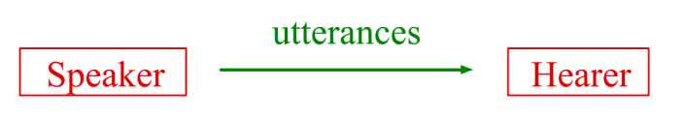

20. image captioning的过程？

detect words -- generate sentences -- re-rank sentences

## 二、DL for NLP

1. 用DL解决NLP的核心思想？

represent words as dense vectors (每个维度都有数字）

2. 用DL解决NLP的方法

Word embedding

N-Grams

RNN

LSTM

3. 什么是text preprocessing

clean and transform raw text 原始文本 data into a format suitable for analysis

4. 什么是tokenization

break down the text into the smallest unit

5. 什么是word frequency

measures how many times that word appears in the entire corpus.

6. 什么是stemming

find the root of words

7. 什么是lemmatization

find the form of the related word

8. 什么是POS/NER tagging

label the words according to their word types

9. 怎么训练一个NER tagger

用HMM

Input layer -- hidden layer -- NER tag/POS tag

10. 什么是Parsing

examine whether a document makes sense by comparing its contents to the principles of formal grammar

process of finding a parse tree for a given input string

11. 什么是parser？

report errors with the syntax

assist the generation of a parse tree

12. 自然语言是context dependent的

13. vector space的好处？

enable the computation of similarity between words (cosine similarity)

14. 怎么构造vector space?

用word embedding

15. 什么是word embedding?

turn words into numbers to use by many ML algorithms

16. embedding的方法？

Word2Vec

17. Word2Vec的两种训练算法？

CBoW (continuous bag of words) predict center word from context（完形填空）

Skip-gram predict context from center word（扩句）

18. CBoW和Skip-gram分别的优势？

CBoW faster to train+大数据work well

Skip-gram suitable for capturing **semantic relationships** between words+小数据well

19.什么是 learned vectors

semantically close words are near each other (dog和cat挨着)

syntactic relationships are preserved with relative positioning (slow-slower和fast-faster的连线方向差不多，首都指向国家的方向差不多)

20. 什么是word analog，步骤是什么

例如：king-man+woman=queen

（1）understand the relationship

（2）apply the relationship

（3）perform the analogy

21. measuring similarity的公式？

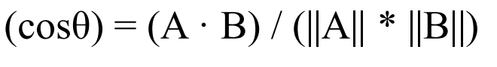

dot product 和 magnitude

22. 什么是sliding window

W是中心词两边的宽度，S是每次挪多少

23. 用sliding window的好处？

learn features of each word on its own , given a text corpus

don’t need heavy preprocessing

word vectors can be used as features for lots of supervised learning applications

24. 什么是language modeling，有什么应用？

assign high probabilities to well-formed sentences

应用：generation, speech recognition, machine translation

25. 什么是N-Grams

N=1的时候就是一个个词地分析

N=2就是分析两个相邻的词

N=3就是三个相邻的一起分析

问题：N=5就是极限了

26. 什么是RNN

use past information without restricting the size of the context

缺点：can’t recall information long time ago

27. 什么是LSTM (long short term memory networks)

（1）can mitigate **vanishing gradient problem**

（2）can handle **long term dependencies**

（3）have **gating mechanism** to regulate the flow of information

（4）have a **memory cell** to store and retrieve information over long sequences

详细版：

（1）can mitigate vanishing gradient problem

（因为it incorporates specialized memory cells amd gating mechanisms to learn and store information over long sequences）

（2）can handle long term dependencies

（因为能够maintain and update **cell states** over time）

（3）have gating mechanism to regulate the flow of information

（allow them to **selectively update** and use information from previous time steps）

（gates that control forgetting, adding, updating, outputting information）

（4）have a memory cell to store and retrieve information over long sequences

## 三、NLP applications

1. ChatGPT模型的原理？

compute the probability of the next token in sequence

2. ChatGPT的核心技巧

unsupervised pre-training techniques

展开讲：help to achieve dialogue generation

automatically learn the laws and features of the language from a large amount of unlabeled data

# Limitations & Future

1. 现在的AI技术有什么限制？

data dependency

interpretability and explainability

generalization

computation and resource requirements

energy consumption

robustness and security

2. 什么是data dependency

AI relies on large amounts of high-quality data for training and learning.

Limited or biased data can lead to inaccurate or biased AI systems

large-scale language model relies on a large amount of data for training

data acquisition can be difficult due to privacy restrictions or costs

3. 什么是Interpretability

many AI algorithms are considered black boxes

it is hard to understand and interpret their decision-making process

4. 什么是Explainability

explain model predictions or decision results.

5. 什么是Domain Shift

（1）a phenomenon in ML and statistics

（2）the **statistical properties of data will change** if it transitions from one domain or distribution to another

（3）occur when a model that is trained on data from one source domain performs poorly when applied to a different target domain

6. 怎么解决Domain Shift

（1）Zero-shot learning

（2）Knowledge transfer

（3）GAN

7. 什么是Computation and resource requirements

AI algorithms require significant computing power and resources

8. AGI是什么组成的

（1）DL+IL+RL=AGI

（IL是模仿学习imitation）

9. AGI有什么

（1）AlphaGo

（2）ChatGPT

（3）AlphaFold

（4）ClimaX

10. AGI会如何发展

（1）from common to professional still many logic and factual mistakes in ChatGPT

（2）more media will be involved

（3）LLMs leverage tools to affect real world

（4）automatic driving

（5）Natural language becomes a new programming language

（6）AI for science ClimaX uses big models for weather forecast